Name: Deployment on Flask

Report date: 28/02/2024

Internship Batch: LISUM30

Version: 1.0

Data intake by: FNU Mrinal Shasta Rajput

# Select data (simple data)

**Tabular data details:**

|  |  |
| --- | --- |
| **Total number of observations** | 1436 |
| **Total number of files** | 1 |
| **Total number of features** | 5 |
| **Base format of the file** | .csv |
| **Size of the data** | 33 KB |

The data contains information on the prices of used cars between the years 1998-2004. The price becomes our predicted value and we use distance covered (KM), Horse power (HP), Gear type (Automatic or Manual) and CC of the car to predict the price.

# The model

I used a linear regression model to predict car price and saved the model by serializing using Pickle.

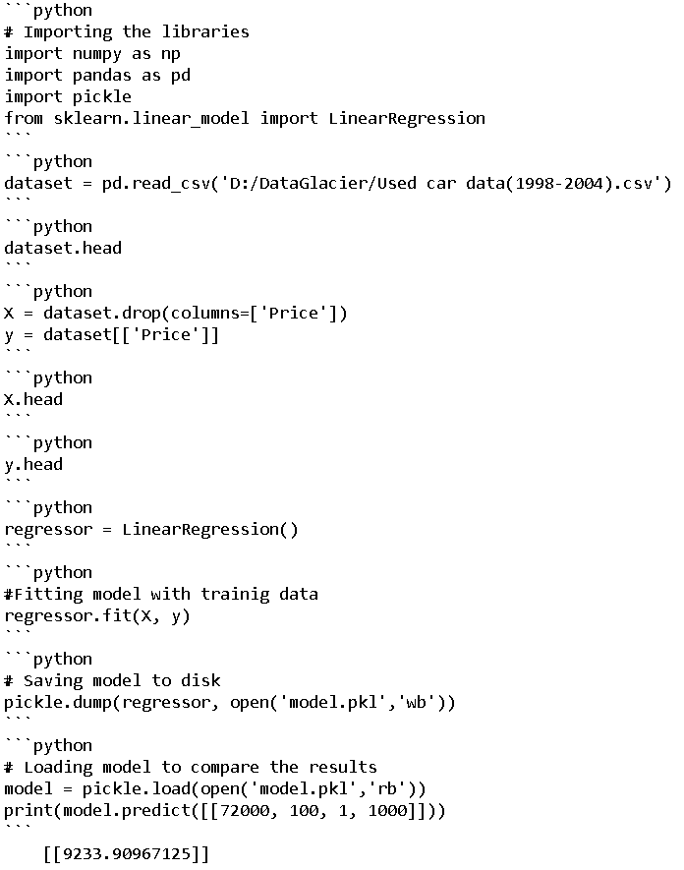

# Deploy the model on flask (web app)

Below is the index file that I used:

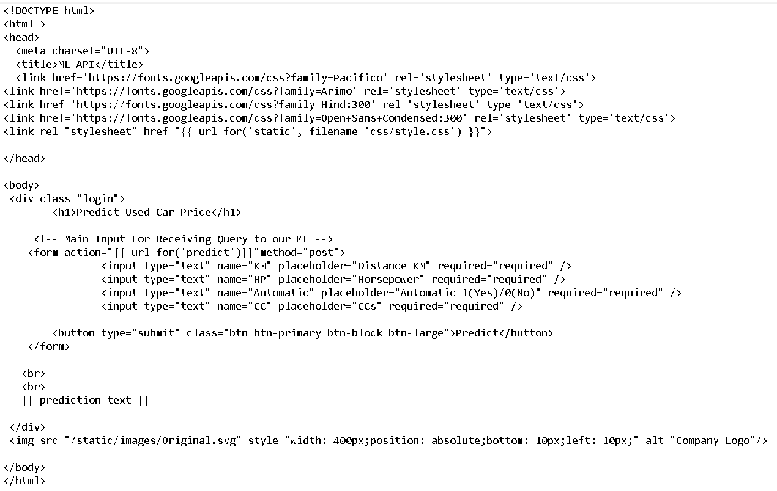

App.py file:

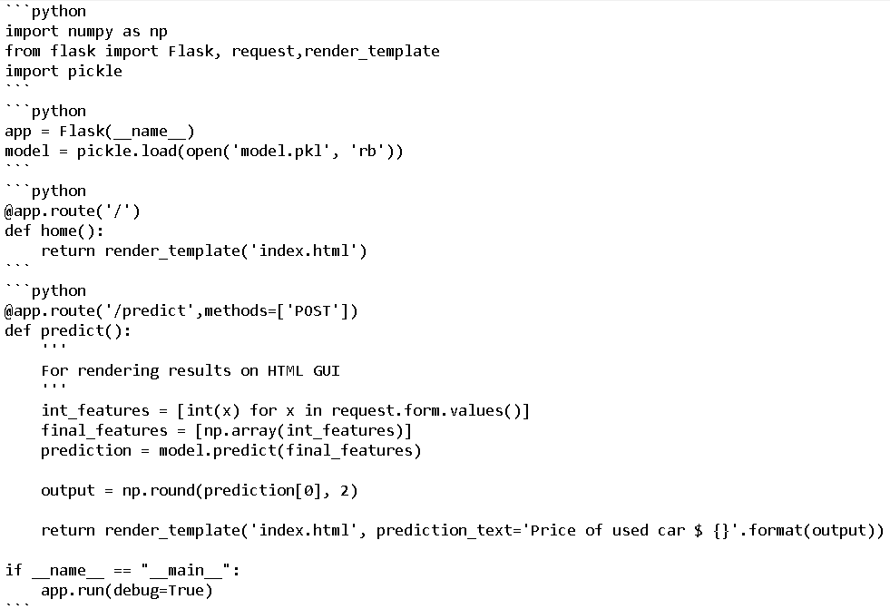

Below in cmd app.py is ran and there we get the url (http://127.0.0.1:5000) to use in chrome:

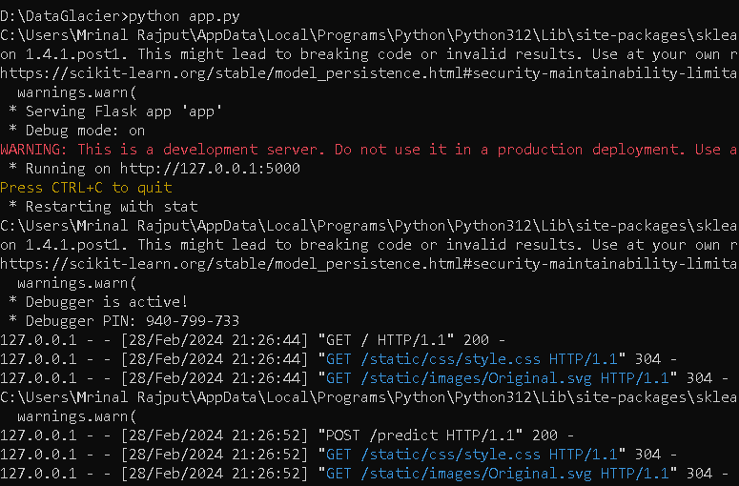

This is the final result:

